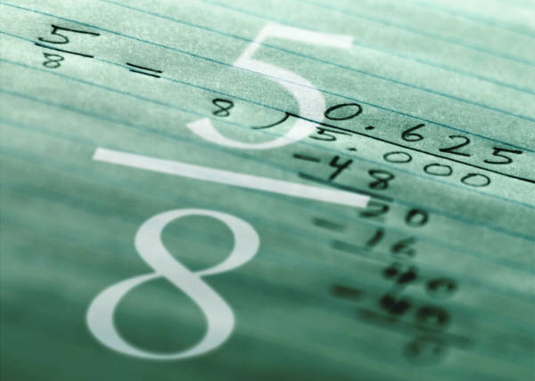
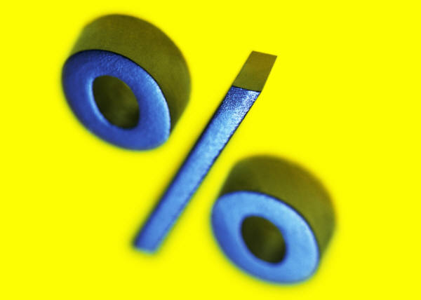
Find the Equivalent

A game for 2 players

You will need: Find the Equivalent Baseboard
Two dice numbered 1-6
About 30 counters (15 each of two different colours)

RULES

- Take turns to throw the two dice and add the two numbers. Look at the grid (below the baseboard) and see which fraction or its equivalent you can cover.

- Choose a square to cover. The winner is the first person to get four counters in a row – horizontally, vertically or diagonally.
My dice total is 8. This means I can cover , 0.4 or 40%
4
10

Find the Equivalent

BASEBOARD

3  10 | 60% | 90% | 50% | 3  4
1  2 | 0.2 | 90% | 90% | 0.5
0.25 | 2  10 | 0.1 | 20% | 0.4
10% | 0.7 | 9  10 | 0.6 | 1  4
4  10 | 6  10 | 2  10 | 40% | 0.8
8  10 | 0.9 | 75% | 25% | 0.75
7  10 | 30% | 0.2 | 70% | 0.3

DICE | 2 | 3 | 4 | 5 | 6 | 7 | 8 | 9 | 10 | 11 | 12
FRACTION | 10  3 | 10  8 | 10  7 | 1  4 | 10  9 | 10  2 | 10  4  4 | 3 | 10  6 | 10  1  2 | 1

Percentage Calculations & Strategies

Mental Maths Activity

Objective: To give pupils opportunities to discuss and use strategies for performing mental calculations with percentages.

You will need: A set of percentage calculation and
percentage strategies cards for each pair of
pupils.
(Photocopy on to card and cut out)
Activity Sheet – The Right Price

Main Activity

- Give each pair of children a set of calculation cards and a set of strategy cards.

- Ask them to match each calculation card to a strategy card.
Tell the children that they do not work out the calculation.

- Discuss how the children have matched the cards. Invite them to give alternative strategies if appropriate.

- Suggest that they use some of the strategies to complete the Activity Sheet “The Right Price”.

- Discuss which calculations were correct and which were incorrect.
Percentage Strategies

Divide by 3 | Divide by 100 and  multiply by 3
Divide by 10 and double  the answer | Divide by 10
Halve the number then halve it again | Divide by 10 and subtract the answer from the number you started with
Divide by 2 | Divide by 10 and then  find half the answer
Halve the number then halve it again and add  the two answers | Divide by 10, halve your answer and add the two numbers together

Percentage Calculations

Find 10% of £1.60 | Find 50% of 420ml
Find 3% of £17 | Find 75% of 840m
Find 20% of £4.90 | Find 90% of 660g
Find 25% of 240 | Find 5% of 3000
Find 15% of 80cm | Find 33¹/₃% of 63

Percentage Wheels

Write the percentages of the centre number in the boxes.

70
90%
50%
20%
10%
5%
80%
90
30%
20%
10%
90%
5%
50%
120
10%
5%
25%
70%
75%
50%
£50
5%
40%
50%
1%
10%
25%
180
75%
15%
60%
5%
20%
50%
£85
5%
90%
70%
10%
50%
1%

Percentage Wheels

Write the percentages of the centre number in the boxes.

%
%
%
%
%
%
%
%
%
%
%
%

%
%
%
%
%
%

%
%
%
%
%
%

%
%
%
%
%
%

%
%
%
%
%
%

Percentage Challenges

Using the Hundred Square

- What percentage of the numbers are:

- even?
- multiples of 5?
- multiples of 7?
- end in 6?
- contain a 4?
- square numbers?
- cube numbers?
- prime numbers?
- triangular numbers?
- factors of 100?

- If all the square numbers were removed what percentage of the numbers would be left?

- What percentage of the numbers are not prime numbers?

- How much greater is the percentage of multiples of 6 than the percentage of multiples of 8?

The Right Price

Alan and Shirley have been calculating how much they will have to pay for some items in a fashion sale. For each item they have calculated the sale price. Mark their answers right ✓ or wrong x and use the correction box to show them how to fix their mistakes.
20% off

15% off

5% off

10% off

25% off

Original Price £36.00

Sale Price £32.40
Right or wrong?
Original Price £42.20

Sale Price £33.84
Original Price £27.00

Sale Price £25.65
Original Price £14.70

Sale Price £12.23
Original Price £76.00

Sale Price £57.00
CORRECTIONS

